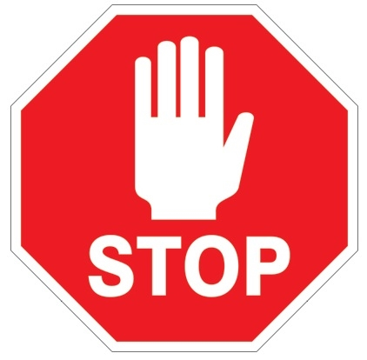

ALL STAFF
BEFORE ENTERING
RESIDENT CARE AREAS

- Remember not to bring any personal items onto unit (purses, cups, cell phones, etc.)

- Ensure long hair is up in a bun and no loose fly a ways

- Perform hand hygiene

- Put on mask, adjust and perform hand hygiene

- Remove your clean eye frames and lenses from bag, assemble and put on

- Perform hand hygiene again and head onto unit

