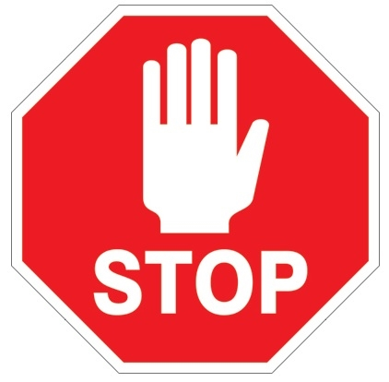
Personal Protective Equipment (PPE)
REQUIRED
by ALL
past these doors

