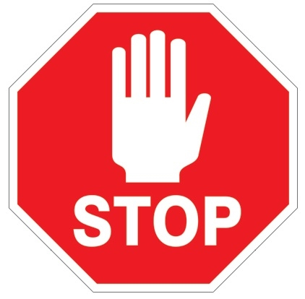

ALL STAFF
WHEN LEAVING FOR BREAK
or END OF SHIFT

- Perform hand hygiene

- Remove your eye protection, separate frame and lens, disinfect with Oxivir wipe (as per protocol), place on clean surface to air dry (ie. paper towel). When dry, place both pieces in plastic bag.

- Perform hand hygiene

- Remove mask CAREFULLY and deposit in garbage

- Perform hand hygiene

